Rainbow Salt Tray
BY Janice Davis ON Jun 5, 2012
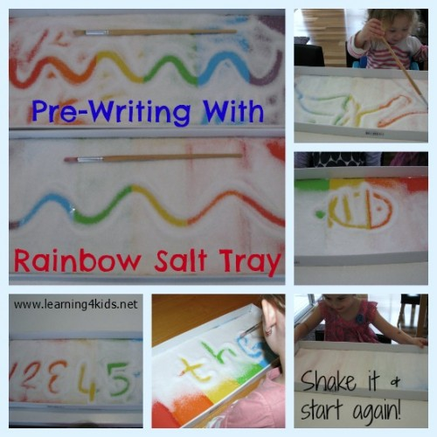
Rainbow Salt Tray is a fun and inviting pre-writing activity.

Why would you need crayons, textas, pencils and paper to draw when you can have more fun with a Rainbow Salt Tray! Draw pictures, create patterns and practise writing your name with this simple to make Rainbow Salt Tray. The greatest thing about a Rainbow Salt Tray is that it is cheap to set up, educational, you will find all the items around the home and it will entertain the littlies for hours!

A Rainbow Salt Tray is a great activity for kids of all ages, my 22 month old had a go and my 6 year old also had a play. I just adapted and encouraged some ideas for them to try as they played.

What you will need?
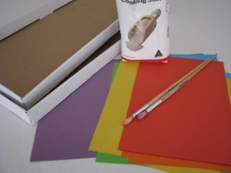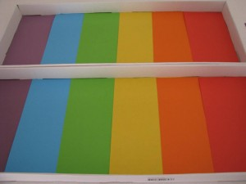

You will need 5 basic things to create your very own Rainbow Salt Tray: about 100g cooking salt, sticky tape, coloured paper, a tray (see below for some ideas) and a paint brush.
- Cut the paper to fit and cover the base of the tray in order of the colours of a rainbow.
- Place sticky tape over the joins of the paper to avoid the salt moving underneath the coloured paper.
- Cover the paper lightly with salt.

Tip: Only a small amount of salt is required for this activity as too much can make it harder to see the drawings. You can also make your tray any colour you would like, possibly your child’s favourite colour, whatever motivates or interests them!

Some ideas to use for a tray:
- The lid to a plastic tub or container.
- A cardboard box with the side cut down to size if needed.
- A medium to large plastic container that has low sides.

Let’s Play
There are SO MANY things you can do with a Rainbow Salt Tray – here are a few ideas to try!
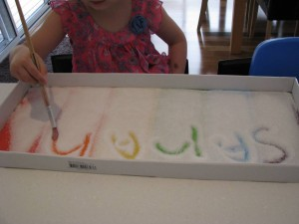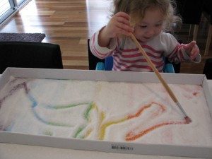

The Rainbow Salt Tray is a great activity for Miss 4 to practise writing her name and for Miss 22 months exploring the cause and effect of what happens when using the paint brush in the salt. I think the look on her face says it all – FUN!

The Rainbow Salt Tray is a fabulous motivator to get kids who need that extra support to learn how to write their names. The fun is watching the colours come through when writing and drawing in the salt.

Let’s Learn
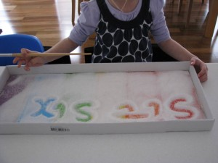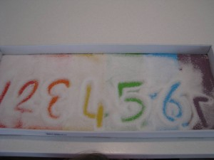

Miss 4 loves her numbers at the moment but is reluctant to try and write the ‘more difficult’ shape numbers such as 2 and 5. She was more willing to have a go in the salt tray because she could so easily shake the tray and try again! I also lightly formed their shaped in the salt for her to copy and trace over.
Miss 6 practising her current sight words, no boring paper and pencils here!

Let’s Explore
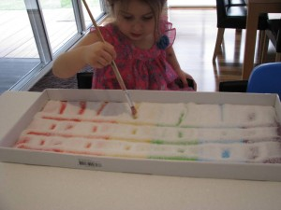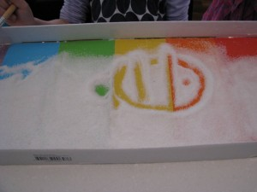

The Rainbow Salt Tray is great for encouraging creativity, with the freedom to make patterns and pictures.

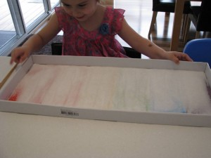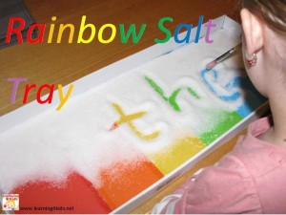

Shake it and start again! Hours of fun!!

Learning benefits of playing with a Rainbow Salt Tray:
- Creativity
- Fine Motor Development – Pre-writing skills
- Hand-Eye Coordination
- Cause and Effect
- Spatial awareness – experimenting with shape and space

